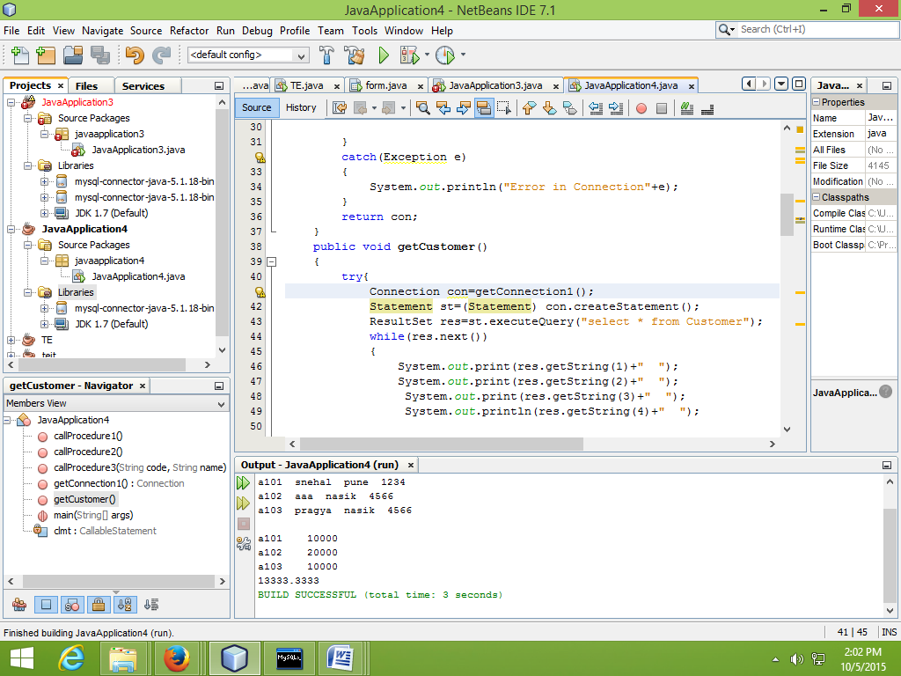

a101 snehal pune 1234

a102 aaa nasik 4566

a103 pragya nasik 4566

a101 10000

a102 20000

a103 10000

13333.3333